**<<AROMA SHOP>>**

**Software Requirement Specification**

– HCM, Mar 2023 –

**Table of Contents**

I. Overview 3

1. Introduction 3

2. System Functions 4

3. Common Requirements 5

II. Functional Requirements 6

1. <<Feature Name 1>> 6

a. <<Function Name 1>> 6

b. <<Function Name 2>> 6

2. <<Feature Name 2>> 6

# Overview

## 1. Introduction

Shop Bán nước hoa ONLINE, hỗ trợ bán nước hoa trực tuyến cho SHOP AROMA TIEN. Cung cấp đầy đủ các chức năng hỗ trợ nhân viên, khách mua thực hiện các hoạt động bán, mua thuận tiện nhanh chóng hơn.

**\*Lưu trữ thông tin khách hàng, yêu cầu đăng nhập bằng tài khoản trước khi đặt hàng.**

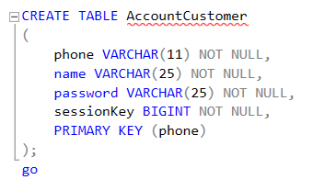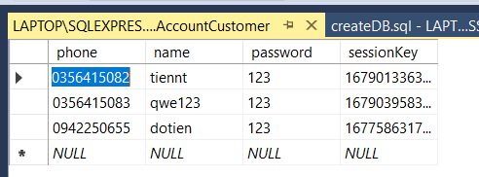

**\*Bảng các thương hiệu nước hoa .**

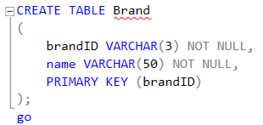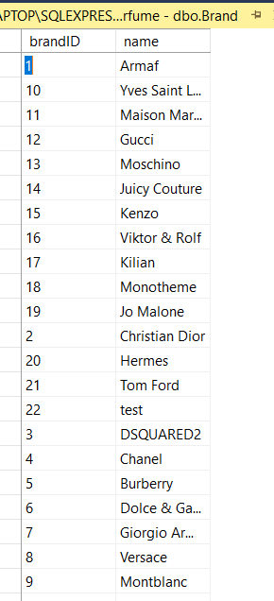

**\*Bảng Type .**

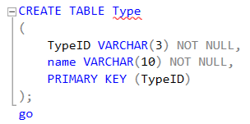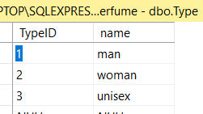

**\*Bảng Products.**

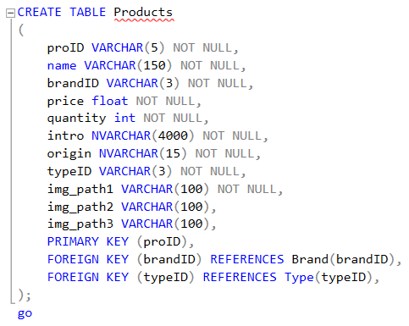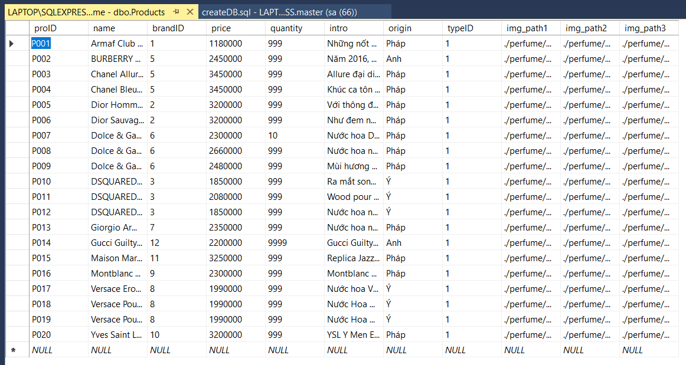

**\*Bảng Invoice.**

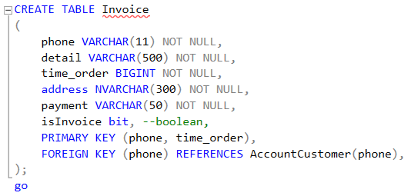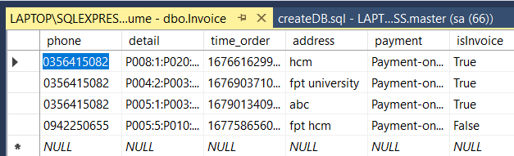

## System Functions

a. Screen Flow

#### 

b. Screen Details

*[Provide the descriptions for the screens in the Screens Flow above]*

***b.1 User Wed Application***

|  |  |  |  |
| --- | --- | --- | --- |
| **#** | **Feature** | **Screen** | **Description** |
| 1 | Home page | Home page | Contains an introduction about “AROMA” and the main features of the application. |
|  | Show each type of perfume | showType page | Separation of perfumes (men, women, unisex) |
|  | Show product’s information | showProduct page | User can view detail perfumer and choose quanity, add to cart. |
|  | Manager Cart | Cart page | CRUD perfumer in cart. |
|  | Order | Order page | Insert address and submit order. |
|  | Login/Logout | .. | .. |

***b.2 Admin Wed Application***

|  |  |  |  |
| --- | --- | --- | --- |
| **#** | **Feature** | **Screen** | **Description** |
|  | Login/Logout | .. | .. |
|  | Admin manager | Admin page | Crud perfumer and invoices. |

# II. Functional Requirements

## 1. Login / Register

* Function trigger: after clicking login button or click the button to milk tea without logging in
* Function description: The system allows users to use their username and password to log in to the system as customer
* Screen layout:

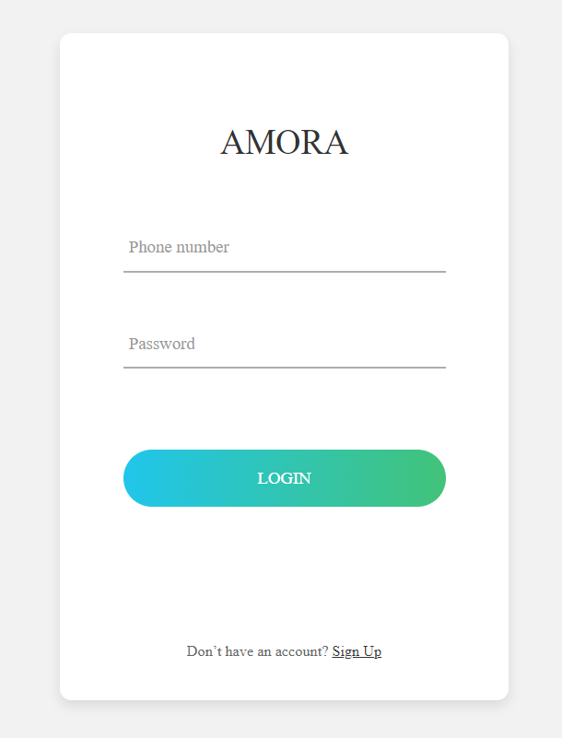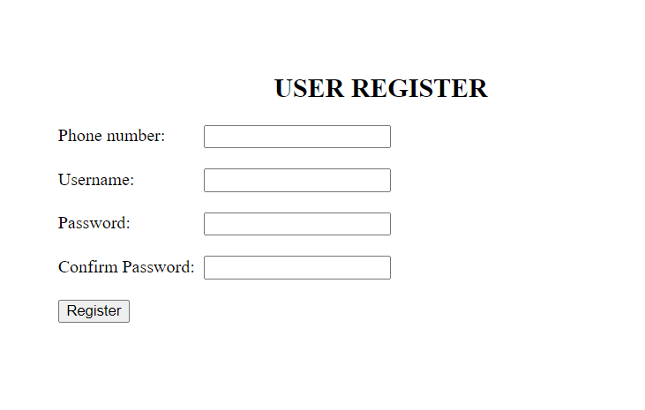

## 2. Show homepage

* Function trigger: after the clicking “Home” link or homepage tab
* Function description: the system shows the homepage for user
* Screen layout:

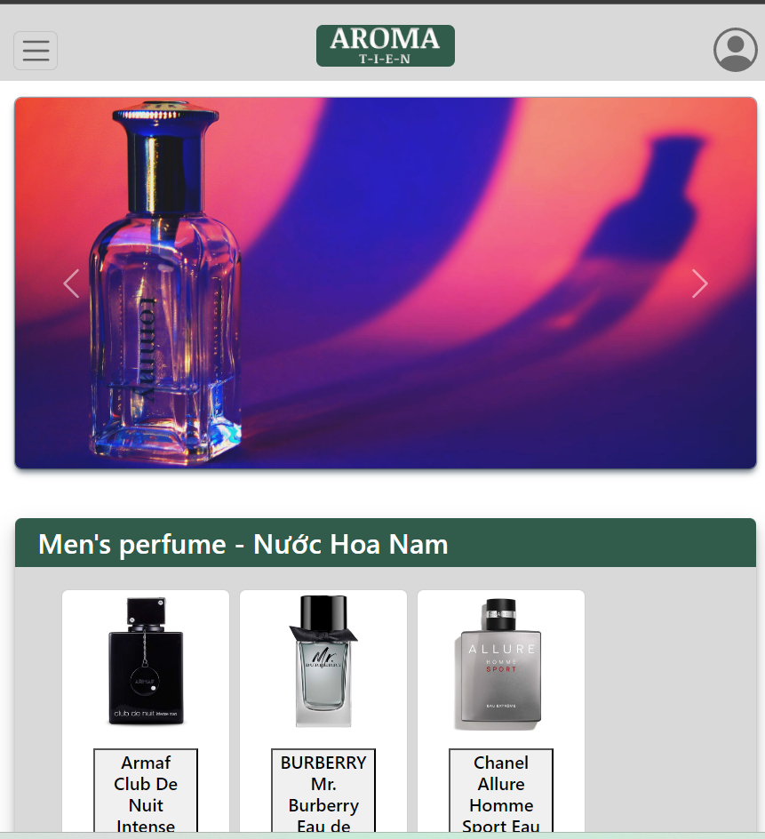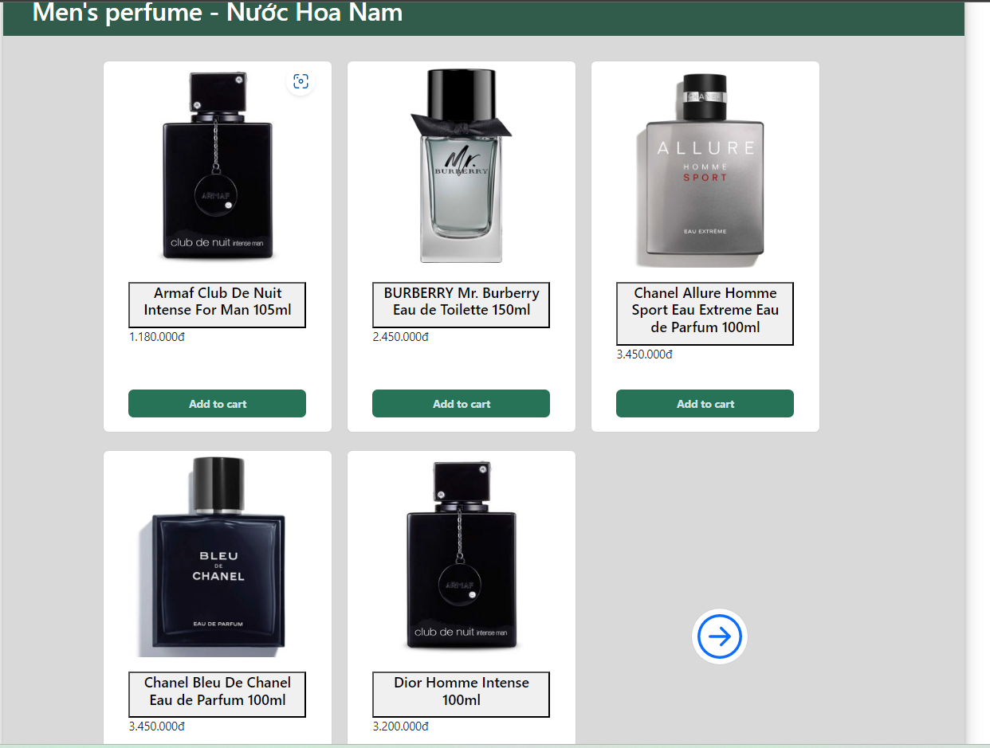

## 3. Show Products belong to type.

* Function trigger: after the clicking “type of perfumer in home page” button or more button in each sections.
* Function description: the system shows list perfumer (types) for user
* Screen layout:

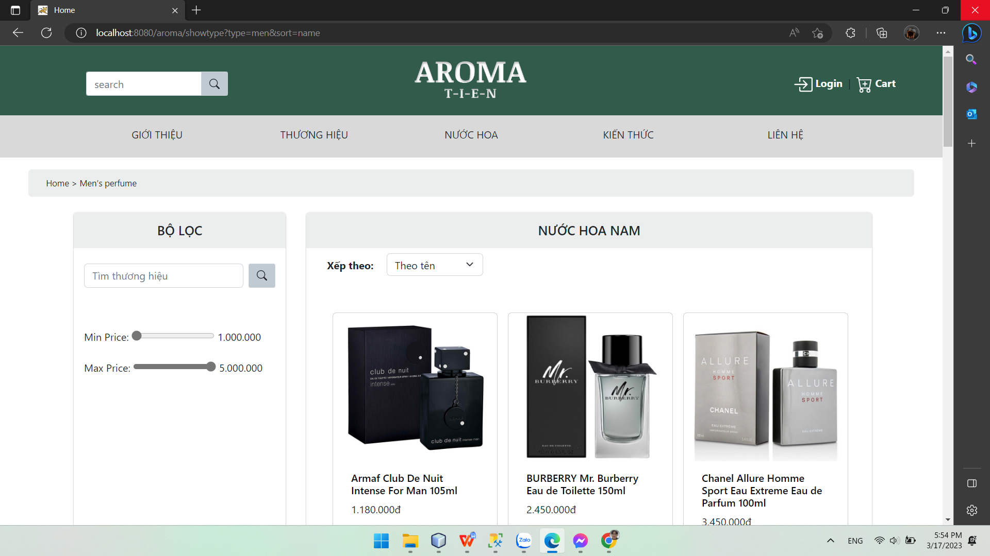

## 4. Show Products detail.

* Function trigger: after the clicking “each product” button in other page.
* Function description: the system shows perfumer (detail) for user
* Screen layout:

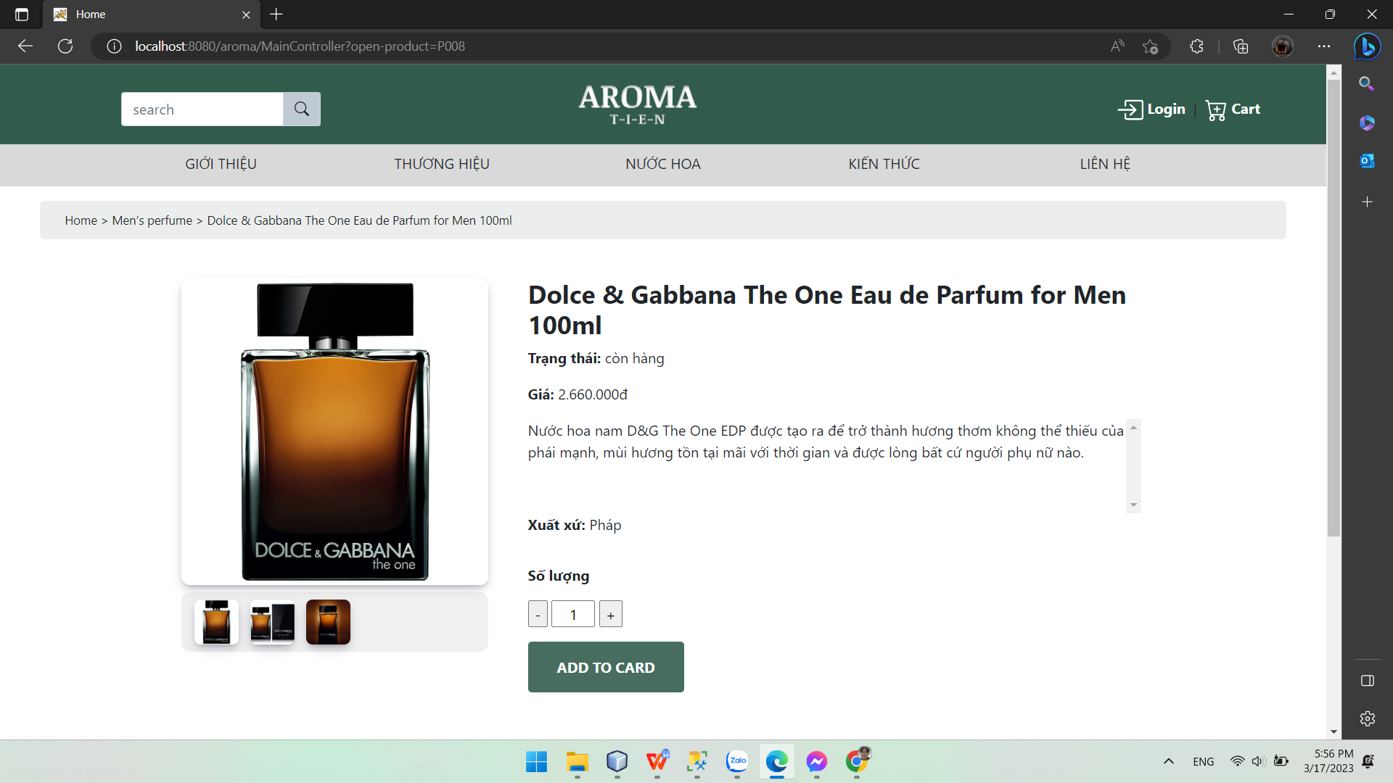

## 5. CART page.

* Function trigger: after the clicking “add to cart” button in other page.
* Function description: product in cart(delete, setup quantity), button to redirect to order page.
* Screen layout:

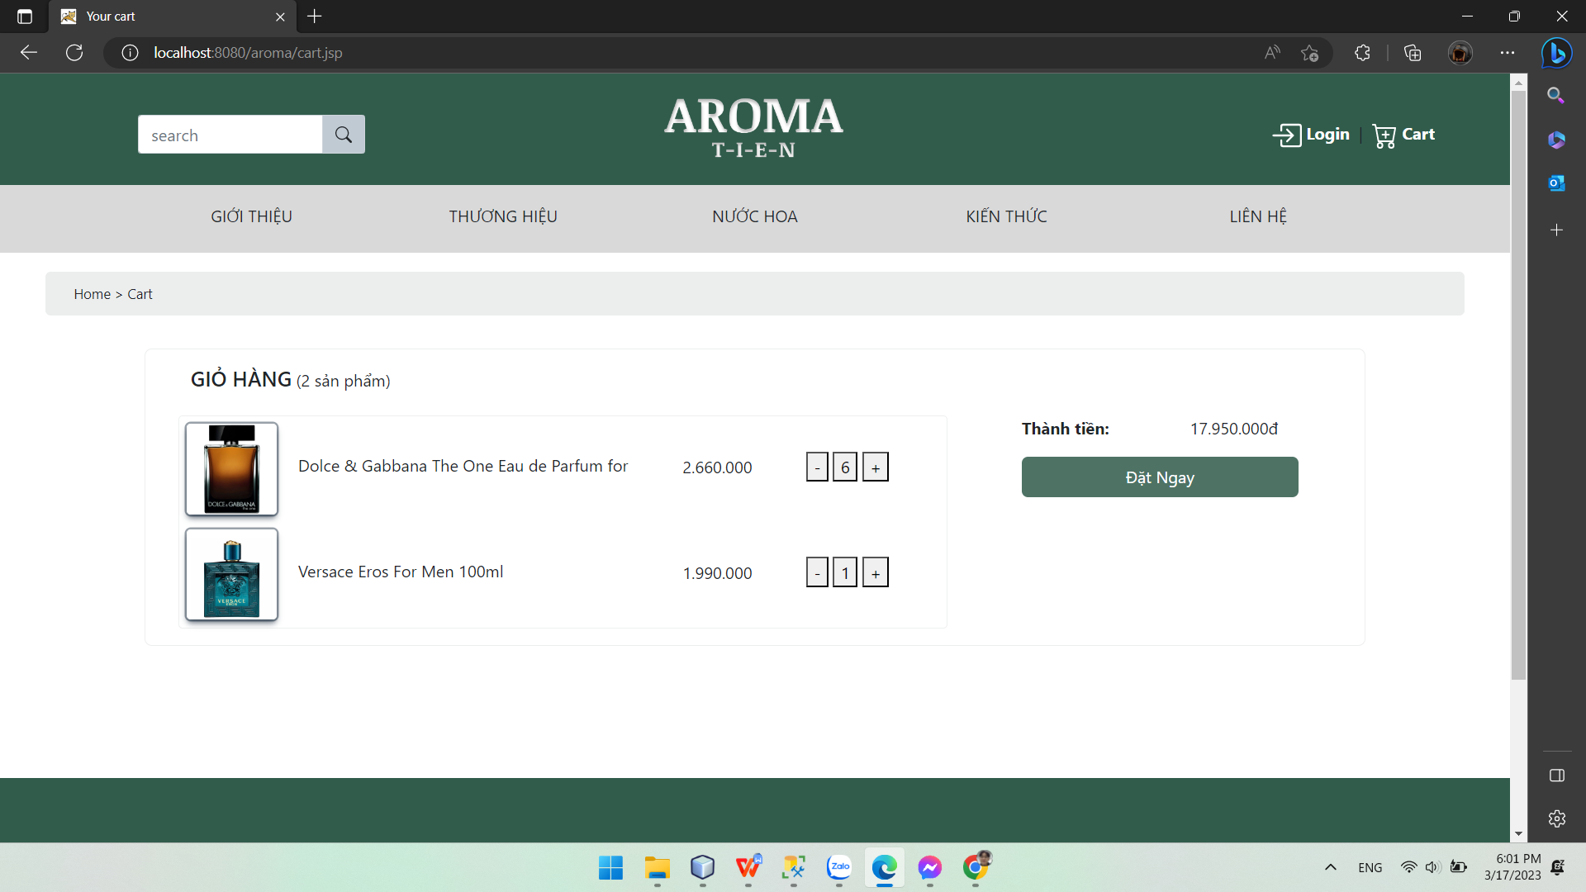

## 6. ORDER page.

* Function trigger: after the clicking “order” button in cart page. Required login.
* Function description: order
* Screen layout:

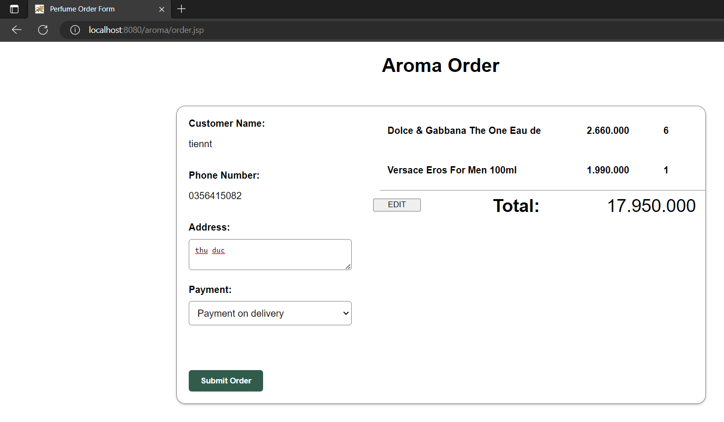

## **7. Admin page.**

* Function trigger: after the checking user password in path:(aroma/admin/).
* Function description: full controll
* Screen layout:

